Website development



Introduction to HTML
- HTML is the standard mark-up language for creating Web pages.
- HTML stands for Hyper Text Mark-up Language.
- HTML describes the structure of Web pages using mark up.
- HTML elements are the building blocks of HTML pages.
- HTML elements are represented by tags.
- HTML tags label pieces of content such as "heading", "paragraph", "table", and so on
- Browsers do not display the HTML tags, but use them to render the content of the page.

HTML Tags
HTML tags are element names surrounded by angle brackets:
- <Tagname>content goes here...</tagname>
- HTML tags normally come in pairs like <p> and </p>
- The first tag in a pair is the start tag, the second tag is the end tag
- The end tag is written like the start tag, but with a forward slash inserted before the tag name
- HTML was created to describe the content of a web page, like:
- <h1>this is a heading</h1>
- <p>This is a paragraph.</p>
- The HTML document itself begins with <html> and ends with </html>.
- The visible part of the HTML document is between <body> and </body>.
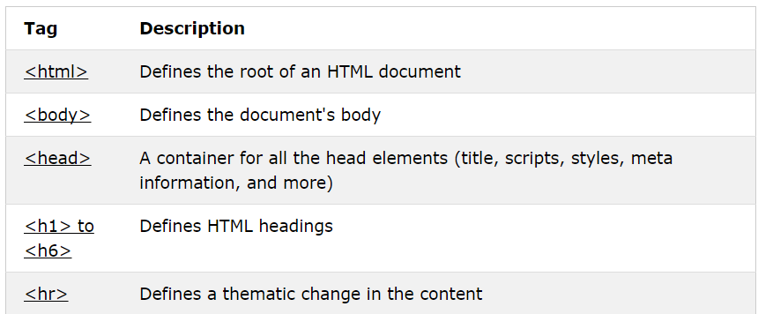
Figure 111-tags with their descriptions
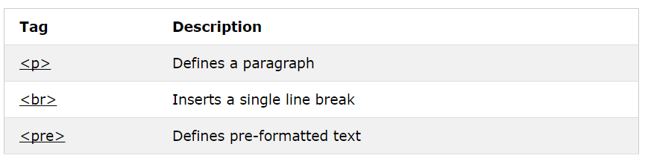
Figure 119- more tags with descriptions

HTML Headings
HTML headings are defined with the <h1> to <h6> tags.
<h1> defines the most important heading. <h6> defines the least important heading:
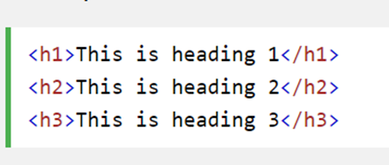
Figure 113-example of heading tags

HTML Paragraphs
HTML paragraphs are defined with the <p> tag:
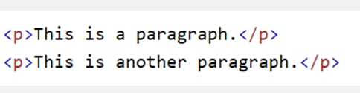
Figure 115-example of paragraph tags

HTML Links
HTML links are defined with the <a> tag:
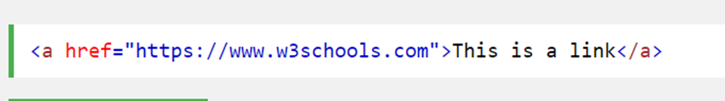
Figure 116-example of links in html

HTML Images
HTML images are defined with the <img> tag.
The source file (src), alternative text (alt), width, and height are provided as attributes:
Figure 117-exaple for inserting image in html

Introduction to CSS
- CSS stands for Cascading Style Sheets
- CSS describes how HTML elements are to be displayed on screen, paper, or in other media
- CSS saves a lot of work. It can control the layout of multiple web pages all at once
- External style sheets are stored in CSS files

CS-141L Introduction to computing Lab 13

Type of Lab: Open Ended Weightage: 10 %
CLO 2: Design a project which builds your logic building skills in collaborative environment.
CLO3: Value plagiarism and ethical guidelines in all lab assignments/homework.
Student Understand the Collaborative environment to design a project. | Cognitive/Understanding | CLO1 | Rubric A
Rubric A: Cognitive Domain
Evaluation Method: GA shall evaluate the students for Question according to following rubrics.
CLO | 0 | 1 | 2 | 3 | 4
CLO2 | Student is not able to use basic tags and write code. | Layout and design is unorganized, background colour is too dark/light, fonts either too big/small. | Layout is organized, Page format fit monitor. Proper background and text colour. | All pages are linked properly using interactive buttons, pages not linked to homepage. | Layout is well-organized and all pages are connected to home page. Task is done excellently.

LAB 14

Design and create a personal website using html and css

Objectives
To learn how to create websites using HTML and CSS in notepad.

Processing steps

Opening Blank Notepads
- Open a new blank Notepad sheet.

Saving these as HTML and CSS
- To save it as HTML file, press Ctrl+S.
- A Save as dialogue box will appear. Select on arrow next to Save as Type and click on All Files from the drop down list.
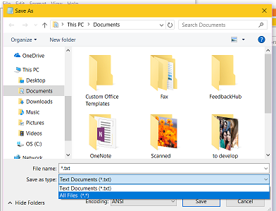
Figure 118-save as type selection
Now type the file name in the bar next to File name and type .html or .htm with the name.
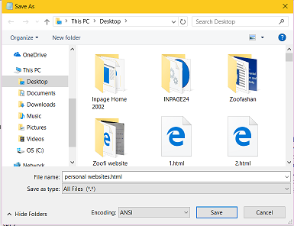
Figure 119-file name with html extension
- Open another blank sheet of Notepad. Save it as CSS file. The procedure is same but name of file will contain .css instead of .html.
- In html file, start the webpage by writing html tag. Then type heading and title of the page.
- Each tag will start with an alligator bracket. And closing of tag is must.

Linking CSS style sheet with HTML
Link the css style sheet with html.
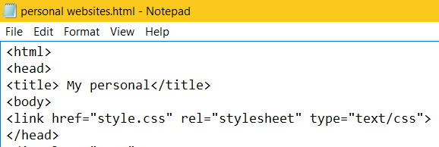
Figure 120-linkin css style sheet with html file
Specify different classes in html file using div.
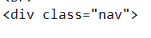
Figure 121-definig class using div in html
Apply designs on the classes in css style sheet. Write dot before name of class, then type bracket {, write design codes, insert semi-colon at the end of each code and close the bracket after designing.
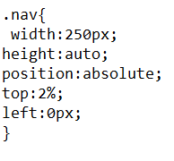
Figure 122-styling of that class in css

Inserting Background image
- Insert background image in css style sheet.
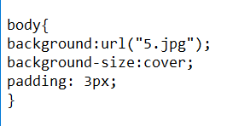
Figure 123-inserting background image in css
- Make navigation tabs and link them with other webpages and links in HTML.
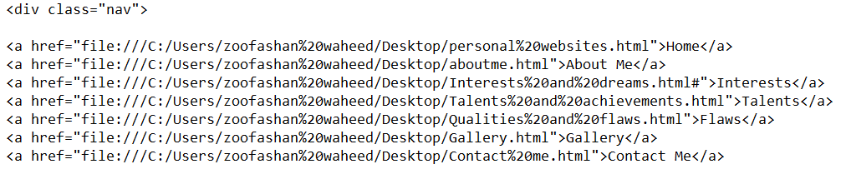
Figure 124-linking with other webpages in html
- And style them in css style sheet.
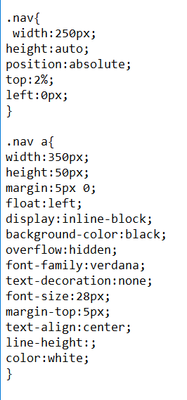
Figure 125-styling of nav bar in css
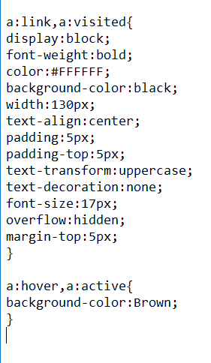
Figure 126: more styling in css
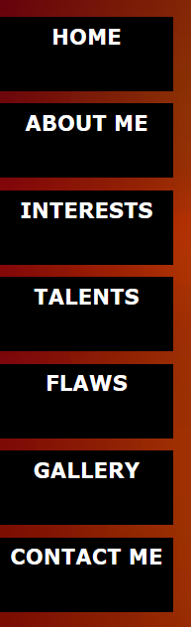
Figure 127-sample of nav tabs in web browser

Inserting box
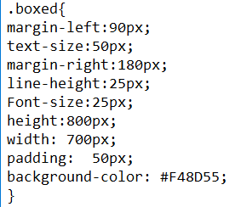
Figure 128-styling of box in css
Insert box and do appropriate styling in css sheet.

Inserting Audio
- Insert audio in html.
Figure 129-inserting audio in html
- Add lists and use <span> to change Colour of words in text in HTML file.
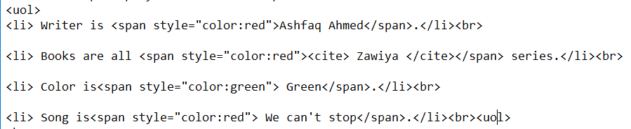
Figure 130-using list and span style in html
Use <cite> to display specific name.
Figure 131-using cite tag to display name of book
Underline the text using<u> tags.
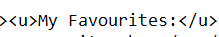
Figure 132-underlining the text

Creating forms
- Create forms in html file.
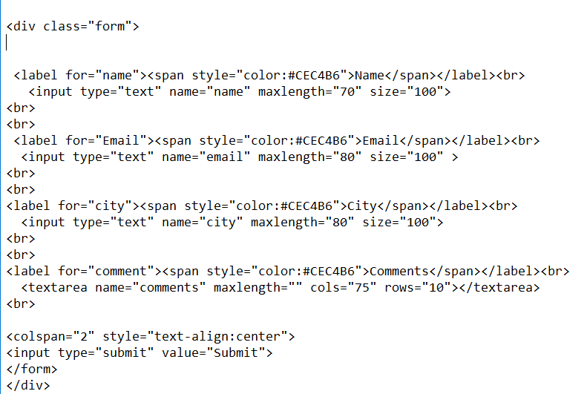
Figure 132: creating form in html
- Insert images and write text along with it in left or right of the image. In this case, I wrote text in right with image.
Figure 133-inserting image on left side of text in html
Save both files by pressing CTRL+S and see results in web browser.

Conclusion
After following the above steps, one can learn how to make a simple personal websites using html and css. By following these steps, one can insert audio, video, images, text formatting etc., and other designing in webpages using css.

Sample:

Figure 120: Sample document

